Pilot High Speed Project Moscow – Kazan Super Train

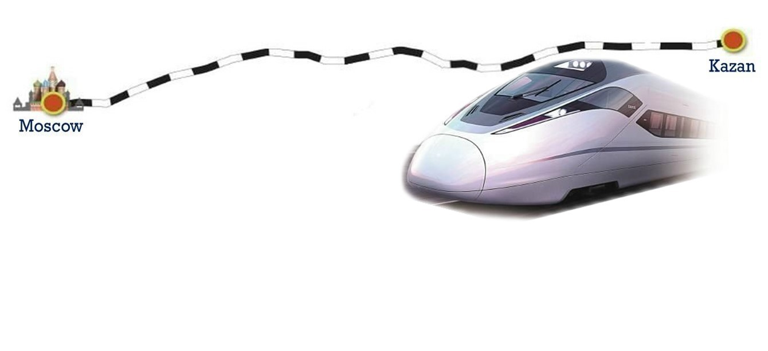

Distance: 700 km with stops in between  
Speed: Top speed 400 km/h  
Current time: 14 hrs – Reduced to 3.5 hrs.

More than 150km of the Moscow-Kazan High-Speed Railway will stretch over artificial structures like 156 bridges, including a 4km-long bridge over the Volga River, 113 overhead crossings and 55 viaducts.

* Expected to complete before the 2018 World Cup in Ufa, Russia

　　　　　　　　　　　　 　 　　Present　　 　High Speed

Moscow – Kazan　　　　　 　　14 hr 07 min　 　3 hr 30 min

Moscow – Nizhny Novgorod　　　3 hr 55 min　 　1 hr 53 min

Nizhny Novgorod – Kazan 　　　10 hr 32 min　 　1 hr 37 min

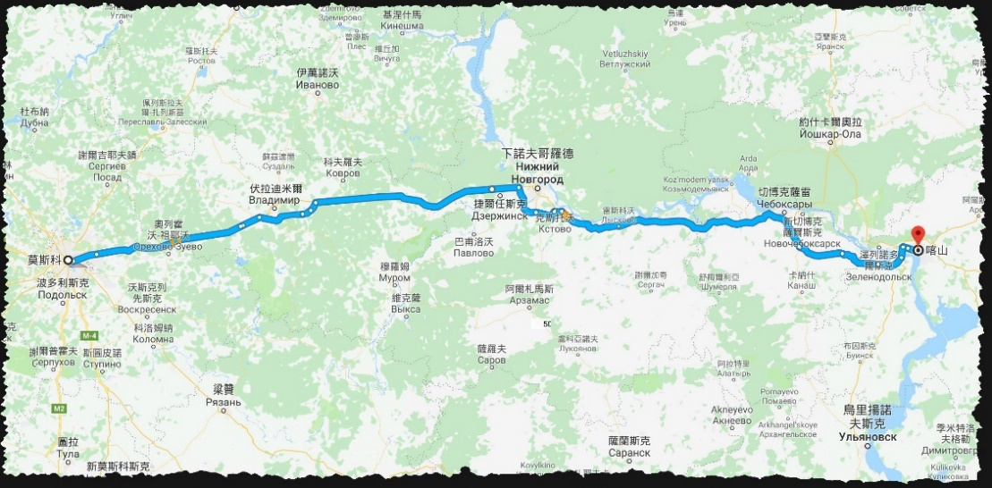

* Total length:770 km Top speed:400 /h Carrying capacity :7863990
* Video: High-speed highway Moscow - Kazan